**1) Create VPC with 2 private and 2 public subnets.**

**2) Enable DNS Hostname in VPC**

**3) Enable Auto Assign Public ip in 2 public subnets**

**4) Add 2 private subnets in private route table**

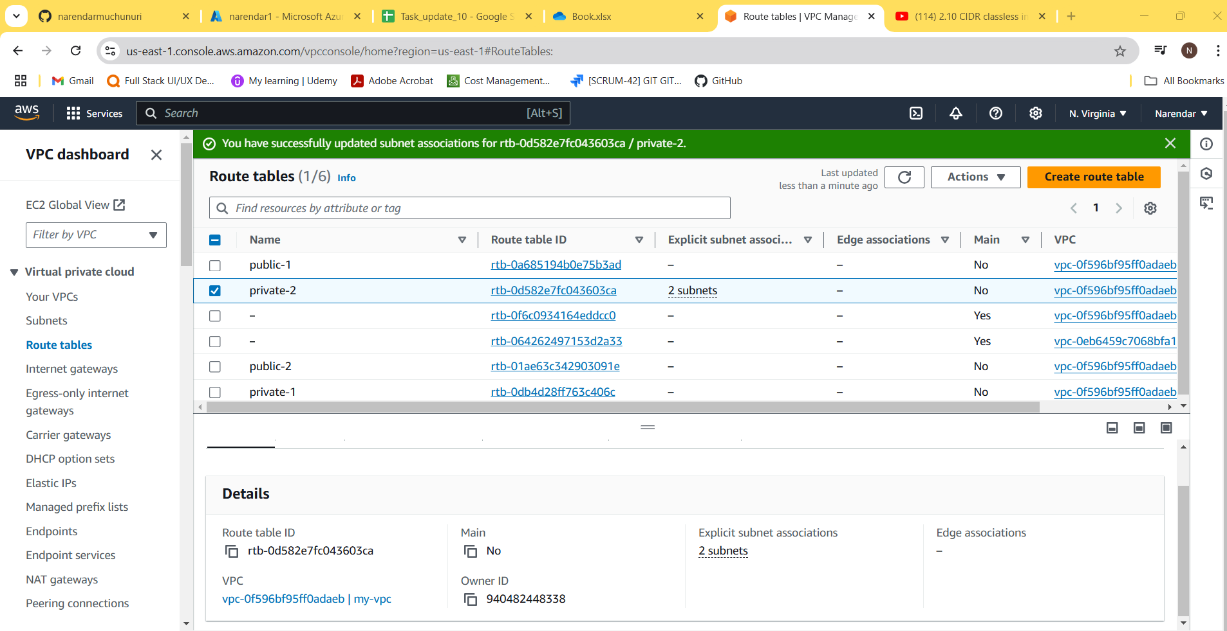

**5) Add 2 public subnets in public route table**

**6) Public route table will have the routes to internet and local**

**7) Create Ec2 in public subnet with t2micro and install php**

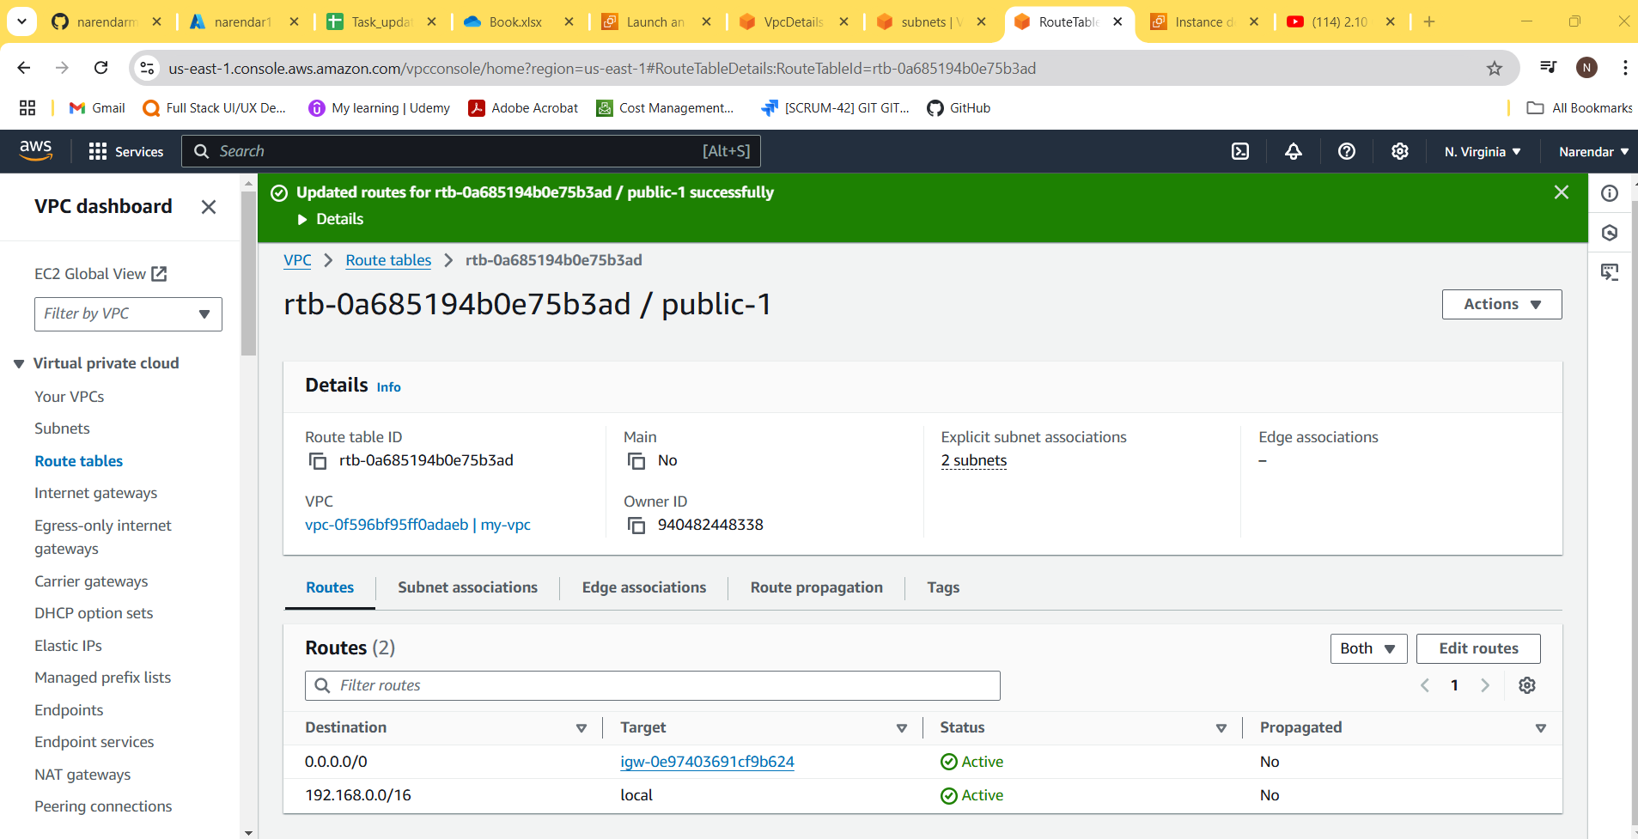

**8) COnfigure Nat gateway in public subnet and connect to private Instance**

**9) Install Apache Tomcat in private ec2 and deploy a sample app.**

**10) COnfigure VPC flow logs and store the logs in s3 and cloudwatch.**

